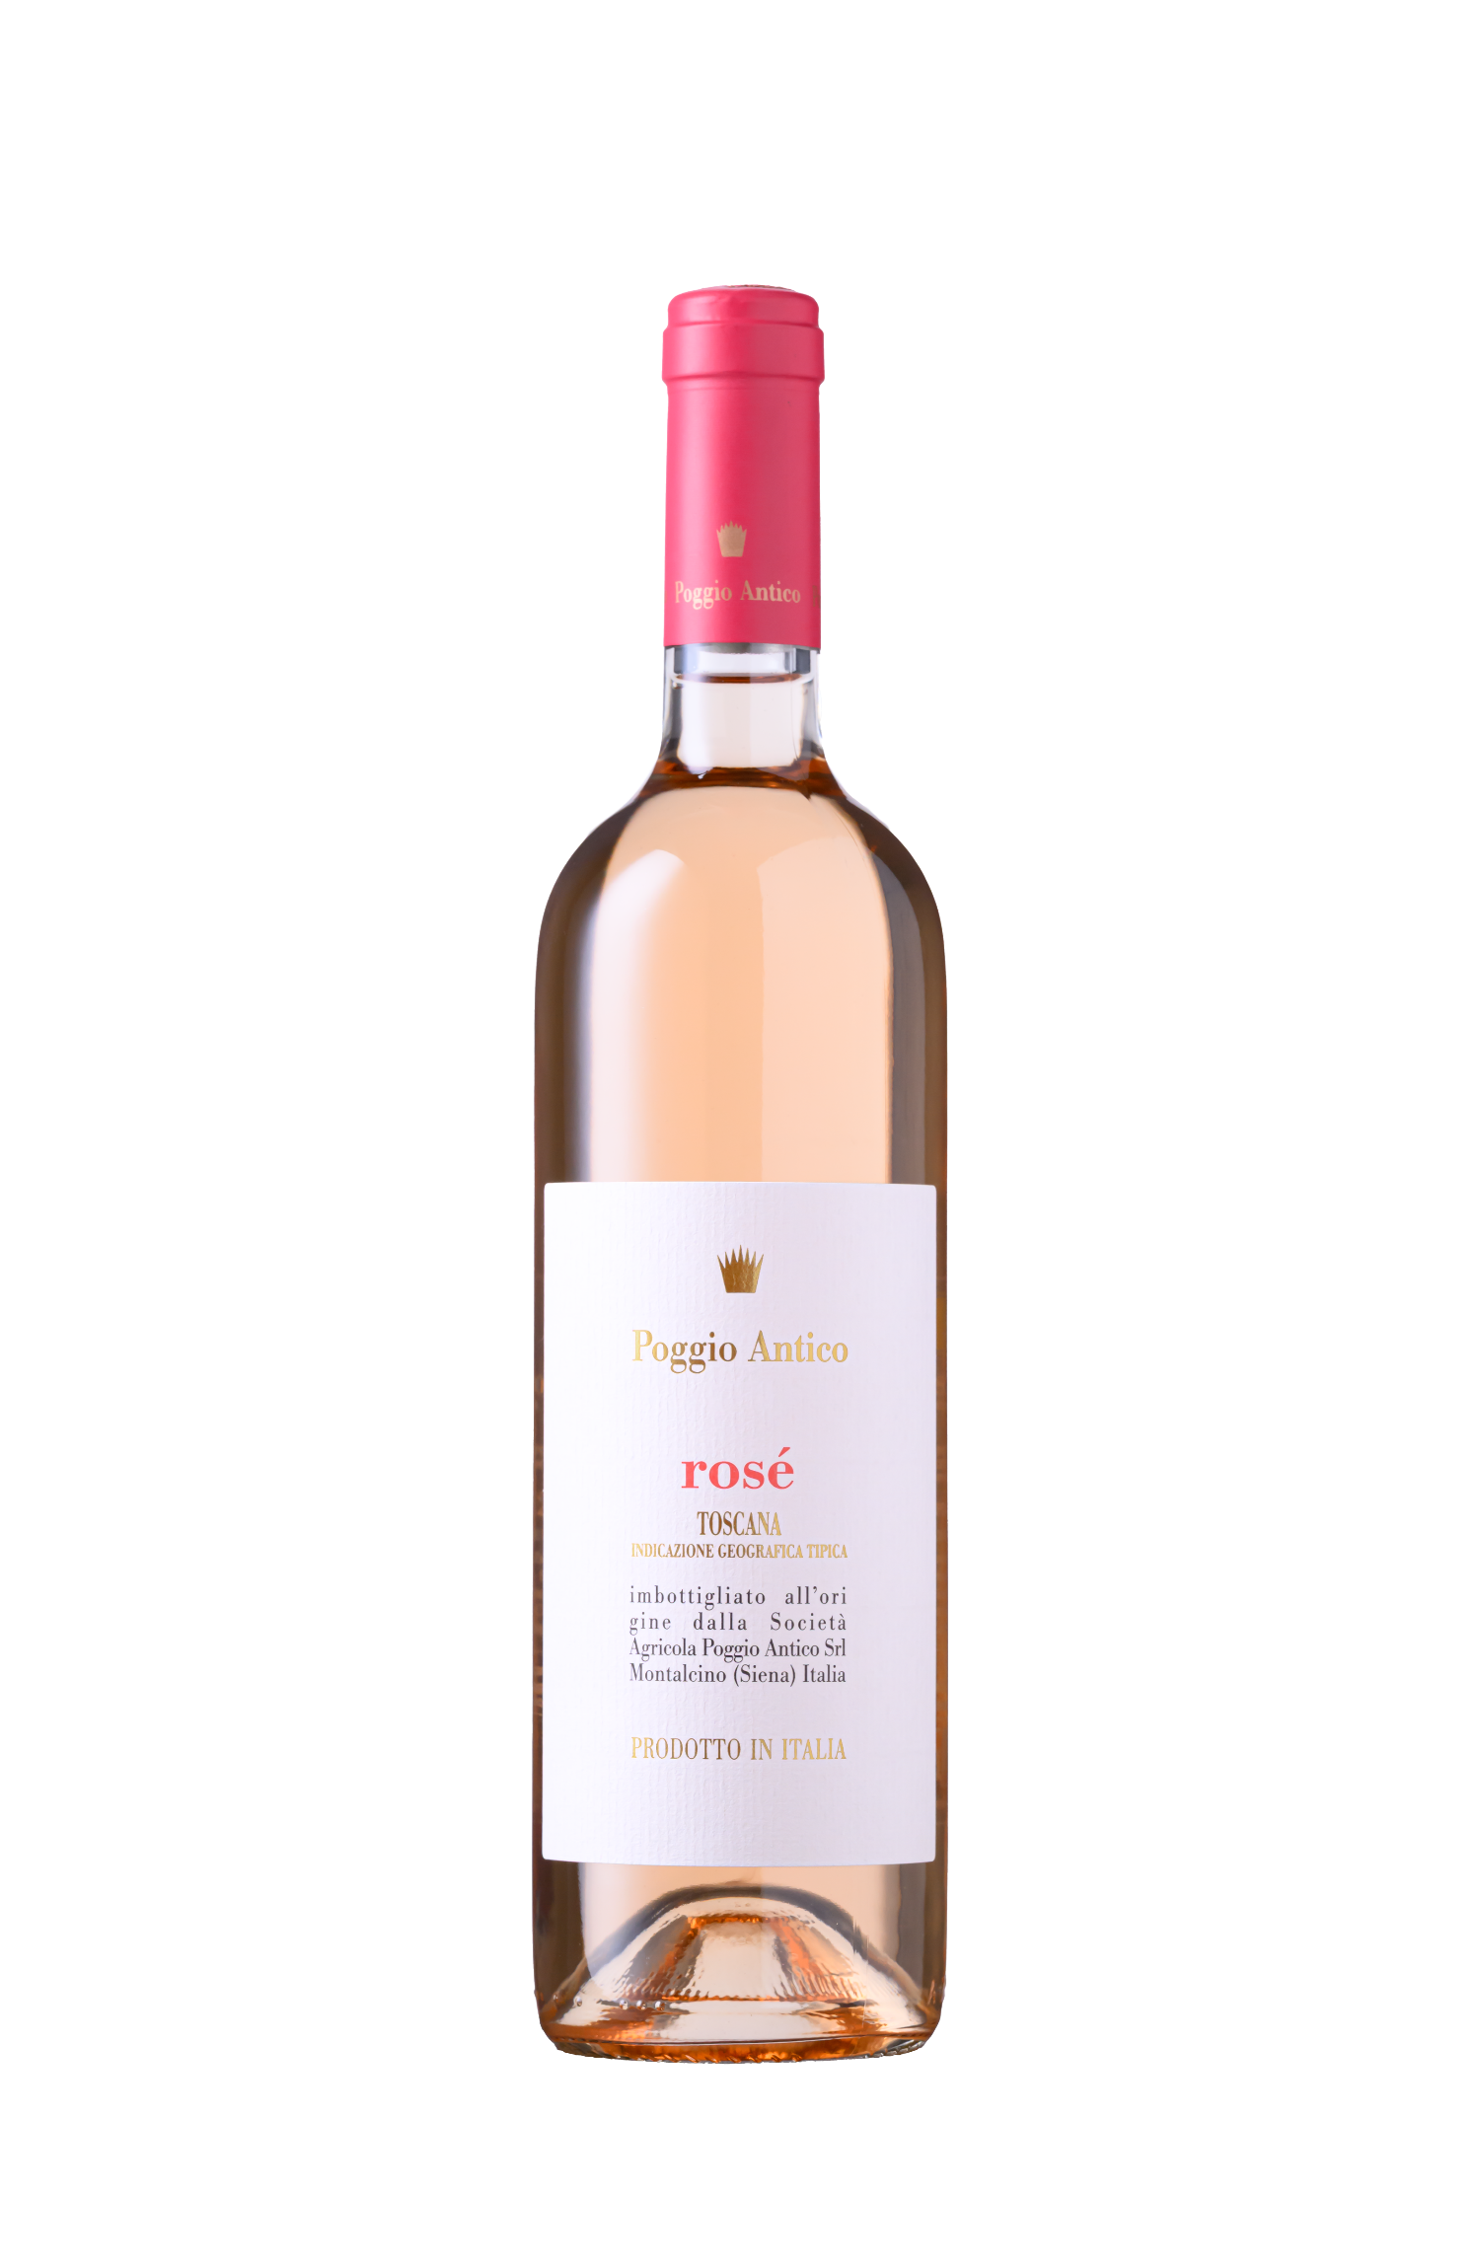

**Altitude:** 480 to 520 m a.s.l. (1574 to 1706 ft).

**Soils:** Deep soils, rich in clay and good water capability.

**Vine training:** spurred cordon and Guyot.

**Grape Varietals:** Sangiovese.

**Winegrowing:** Organic and sustainable farming. Green manuring and cover cropping are applied as needed to balance nutrients, improve porosity, and reduce erosion. Pruning is tailored to vineyard age, soil type, vigor, and exposure to minimize stress and enhance longevity. Copper, sulfur, and natural antagonists combat pathogens. Natural manure boosts soil vitality, and plant fortifiers strengthen vines' defenses.

**Harvest:** Hand-picked grapes onSeptember 11th.

**Harvest Notes:** The 2024 vintage in Montalcino was marked by a mild, dry winter followed by an unusually rainy spring, with frequent and abundant rainfall between April and June. Persistent humidity required careful vineyard monitoring to prevent the onset of disease, particularly during budbreak and fruit set. Agronomic interventions were essential to maintain a balanced vine growth and fruit production. Summer then settled into high temperatures and limited rainfall, supporting a steady and gradual ripening of the grapes.

**Vinification:** 70% fermented in stainless steel tank for 12 days at 18°C. Matured for 6 months on lees.

30% fermented in French barriques and matured for 6 months on lees. Weekly bâtonnage.

**Bottling:** February 2025.

**Production:** 2.900 bottles.



**2024**

**Rosé**

I.G.T. Toscana

Località Poggio Antico - 53024 Montalcino (SI) Tel. (+39) 0577 848.044 - e-mail: [mail@poggioantico.com](mailto:mail@poggioantico.com)

[**www.poggioantico.com**](http://www.poggioantico.com/)